SUBJECT: HEALTH EDUCATION CLASS: K.G
1. Is it good to play with sand (a) yes (b) No
2. Is it good to play with sharp object. (a) yes (b) No
3. Mention these sharp objects
_______________
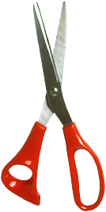

______________

4. Is it good to cut your finger nails short (a) Yes (b) No
5. Is it good to wash your hands all the time. (a) Yes (b) No
6. Is it good to care for our hand (a) yes
(b) No
7. Is it good to pick something from the floor and eat (a) yes (b) No
8. Is it good to do physical exercise (a) Yes (b) No
9. Is it good to wash your fruits before eating them. (a) yes (b) No
10. Mention these fruits
